**REAL TIME RIVER WATER QUALITY MONITORING AND CONTROL SYSTEM**

**AIM :**

To develop a real time river water quality monitoring and control system using Internet of things.

**ABSTRACT :**

One of the foremost important issues for inexperienced globals is water contamination. period watching of the standard is needed to a secure supply of water. the planning and implementation of AN occasional value system for period IOT water quality watching are given during this study (internet of things). so as to live the physical and chemical characteristics of the water, the system uses a variety of sensors. many alternative water quality indicators square measure monitored, together with temperature, pH, turbidity, and flow sensing elements. Commonly, the core controller processes the measured values from the sensors. a necessary controller is the Arduino model. Last but not least, the sensing element knowledge square measure of times examined online over WI-FI. Water treatment watching systems square measure presently divided into manual and dynamic systems. Due to, the constant changes in water, either thanks to seasonal changes in water chemistry or thanks to the operative conditions of the economic atmosphere, the dynamic systems got to be utilized by the water makers. However, water is incredibly useful for all times and human health, so to scale back the endangerment of pollution, by rising and increasing the plant operation additionally to production. This paper suggests a replacement technique for water mill makers by adopting wireless sensing element nodes. The monitor node connected with a microcontroller device victimization Esp32 as transmitter and receiver nodes. The node sends its statues over the wireless network utilizing an outlined web protocol (IP). The projected system shows its effectiveness in the water watching systems through synchronous water watching and easy configuration compared to ancient systems.

**LITERATURE SURVEY :**

Nikhil Kedia entitled “Water Quality Monitoring for Rural Areas-A Sensor Cloud Based Economical Project.” Published in 2015 1st International Conference on Next Generation Computing Technologies (NGCT-2015) Dehradun, India. This paper highlights theentire water quality monitoring methods, sensors, embedded design, and information dissipation procedure, role of government, network operator and villagers in ensuring proper information dissipation. It also explores the Sensor Cloud domain. While automatically improving the water quality is not feasible at this point, efficient use of technology and economic practices can help improve water quality and awareness among people.[1] Jayti Bhatt,Jignesh Patoliya entitled “Real Time Water Quality Monitoring System”.This paper describes to ensure the safe supply of drinking water the quality should be monitored in real time for that purpose new approach IOT (Internet of Things) based water quality monitoring has been proposed. In this paper, we present the design of IOT based water quality monitoring system that monitor the quality of water in real time. This system consists some sensors which measure the water quality parameter such as pH, turbidity, conductivity, dissolved oxygen, temperature. The measured values from the sensors are processed by microcontroller and this processed values are transmitted remotely to the core controller that is raspberry pi using Zigbee protocol. Finally, sensors data can view on internet browser application using cloud computing.[2] Michal Lom, Ondrej Pribyl, Miroslav Svitek entitled “Industry 4.0 as a Part of Smart Cities”. This paper describes the conjunction of the Smart City Initiative and the concept of Industry 4.0. The term smart city has been a phenomenon of the last years, which is very inflected especially since 2008 when the world was hit by the financial crisis. The main reasons for the emergence of the Smart City Initiative are to create a sustainable model for cities and preserve quality of life of their citizens.

**PROBLEM STATEMENT :**

Water is a limited resource that is essential for industry, agriculture, and human existence as well as the survival of every other species on the earth. Many individuals don't realise how important it is to regularly consume enough water. Numerous unrestrained techniques waste more water. Poor water distribution, inefficient use, and a lack of professional and comprehensive water management are all causes of this issue. A house or office's water management system may therefore be limited by efficient usage and water monitoring. Supply is assured due to rapid urbanization .Supply is assured due to rapid urbanization  Drinking water is a challenge for all city administrations. Water can become contaminated at any time. So we reserved water in a rooftop or underground aquarium Your office or home may not be safe. mostly still in India people who are unsatisfactory with a simple water purifier Certainty to pure water. Sometimes water is hazardous particulate or chemical mixtures and general It cannot be cleaned with a special water purifier. and it is Impossible to manually check each water quality. Therefore, it is an automatic real-time monitoring system. It is necessary to monitor the condition of the secured water. Our cisterns of  society and dwellings. so I can warn you Automatically if there is a problem with the reservation water. You can check the water quality at any time and from anywhere. In keeping with that spirit, we designed This system is specialized for residential areas.

**PROJECT DESCRIPTION :**

The online application allows for monitoring of river water quality and can determine whether or not the water contains any dust particles. The water's PH level may be checked. It is possible to check the temperature of the water. Notifying the authorities if the water quality is poor so they may go and warn the community not to consume that water. Our goal is to develop a system for real-time quality assessment for water health in residential places. pH, Turbidity and Temperature sensors are used to gather the parameters necessary to monitor water health in real time.

**METHODOLOGY:**

The system is used to monitor the quality of water with the support of information sensed by the sensors dipped in water. Using different sensors, this system can collect various parameters from water, such as pH, dissolved oxygen, turbidity, conductivity, temperature, and so on. The rapid development of technology provides a novel approach to real-time data acquisition, transmission and processing. The clients can get ongoing water quality information from far away.

**SYSTEM ARCHITECTURE:**

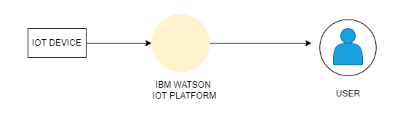

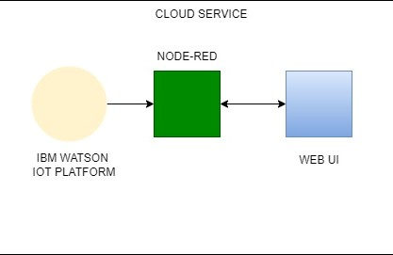

**OVERALL ARCHITECTURE:**

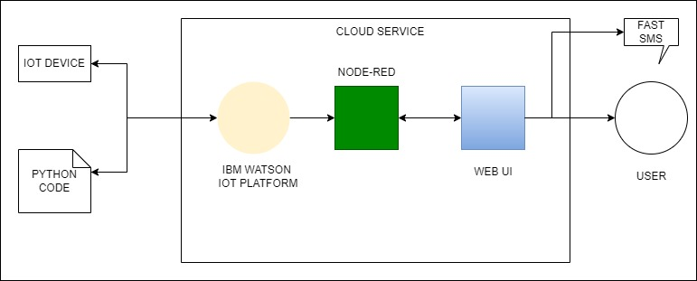

**FEATURES:**

● To measure various chemical and physical properties of water like pH, temperature, and particle density of water using sensors.

● Send the data collected to display and send it to a cloud-based Database using a Wired/Wireless Channel.

● Trigger alarm when any discrepancies are found in the water quality.

● Data visualization and analysis using cloud-based visualization tools.

**PROPOSED SYSTEM:**

The main aim is to develop a system for continuous monitoring of river water quality at remote places using wireless sensor networks with low power consumption, low cost, and high detection accuracy. pH, conductivity, turbidity level, etc. are the limits that are analysed to improve the water quality. Keeping the quality of water in check at all times and notify the user whenever there is a sudden change in the quality or if the quality drops below the required one.

**FUNCTIONAL REQUIREMENTS:**

* River water quality can be monitored by the web application.
* Can be able to know if there are any dust particles present in the water.
* The PH level of the water can be monitored.
* Water temperature can be monitored.
* Alerting the authorities if the water quality is not good so that they can go and announce the localities not to drink that water.

**NON-FUNCTIONAL REQIREMENTS:**

**Performance Requirements**

The system shall be able to handle multiple requests at any given point in time and generate an appropriate response.

* The response should not take longer than 5 seconds to appear on the client side.
* The client application should lazy load images of the product to minimize network calls over the network.
* The responses from the server should be cached on the client side.

**Security Requirements**

* Credentials and secrets should be stored securely and should not be leaked.
* Secured connection HTTPS should be established for transmitting requests and responses
* between client and server.
* The system has different roles assigned to a user and every user has access constraints.
* User access token should be valid for a shorter period and needs to be refreshed
* periodically.
* Clients should implement mechanisms to prevent XSS attacks.
* The server should restrict access to the resources for the particular client domain.

**Error Handling**

* The system should handle expected as well as unexpected errors and exceptions to avoid termination of the program.
* Appropriate error messages should be generated and displayed to the client.

**HARDWARE REQUIREMENTS:**

* 8GB RAM
* Intel Core i3
* Laptop/Desktop
* Windows/MAC/Linux OS.

**SOFTWARE REQUIREMENTS:**

* Python
* IOT Cloud Platform
* IBM Watson
* Node-RED
* IBM DB

**CONCLUSION:**

The River Water Quality Monitoring System uses various sensors to check the quality of water, collects and compares the data with the given one and determines the quality of water. Real-time monitoring of water quality by using IOT will immensely help people to become conscious against using contaminated water as well as to stop polluting the water. An application is designed to improve the user interface between the user and system. This project can be extended into an efficient water management system of a local area. Moreover, other parameters which wasn’t the scope of this project such as total dissolved solid, chemical oxygen demand and dissolved oxygen can also be quantified.

**REFERENCE:**

[1] Sridharan, S. (2014) Water Quality Monitoring System Using Wireless Sensor Network. International Journal of Electronic Communications Engineering Advanced Research,3,399-402

[2] Losilla, F., Garcia-Sanchez, A.-J., Garcia-Sanchez, F., Garcia-Haro, J. and Haas, Z.J. (2011) A Comprehensive Approach to WSN-Based ITS Application. Sensors, 10, 10220-10265. <http://dx.doi.org/10.3390/s111110220>

[3] Mo Deqing, Zhao Ying, Chen Shangsong, “Automatic Measurement and Reporting System of Water Quality Based on GSM,” 2012 International Conference on Intelligent System Design and Engineering Application.

[4] Nikhil Kedia, Water Quality Monitoring for Rural Areas- A Sensor Cloud Based Economical Project, in 1st International Conference on Next Generation Computing Technologies (NGCT2015) Dehradun, India, 4-5 September 2015. 978- 1-4673-6809-4/15/$31.00 ©2015 IEEE

[5] Jayti Bhatt, Jignesh Patoliya, Iot Based Water Quality Monitoring System, IRFIC, 21 feb, 2016.

[6] Michal lom, ondrej priby & miroslav svitek, Internet 4.0 as a part of smart cities, 978-1-5090- 1116-2/16/$31.00 ©2016 IEEE